Seamless Rigging’s Fully Stowless Main Deployment Bag Directions. SeamlessRigging.com
Triangle Tail Installation Instructions
- After proper installation of your new Seamless Rigging bag per manufacturer’s instructions you will need to now install the optional Triangle Tail.
- The Triangle Tail is designed to work in conjunction with the grommet and webbing installed on the top of your Seamless Rigging Stowless Bag. The tail needs to be sewn on at the proper distance from the bag, approx. 8”. This allows the tail to pull in conjunction with the existing system.
- When viewed from the side after installation the bridle and tail should both be taught when pulling on the bridle. (Diagram 1)
- Multiple parallel straight stitches may be used or a small bartack on either side of the kill line 3/4” from the top of the triangle tail; to the bottom of the support tape at the triangle tail apex. Do not sew thru the kill line for this could inhibit the pilot chutes function.(Diagram 2)
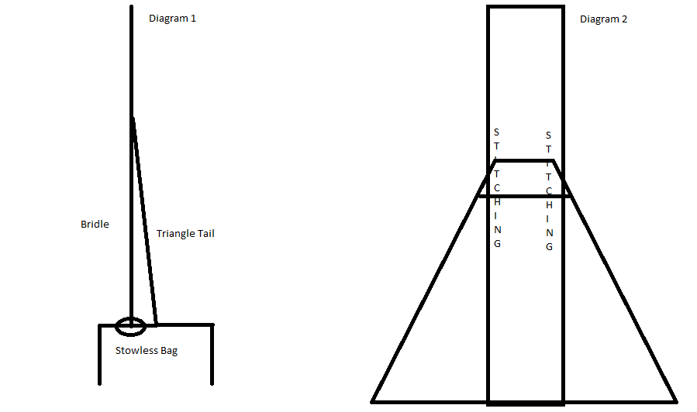

WARNING: Skydiving in dangerous. Having no control over the use of these products, we assume no liability connected with their use. Under no circumstances are we liable for any loss, damage, or expenses of any kind arising out of the use or inability to use our products.

